



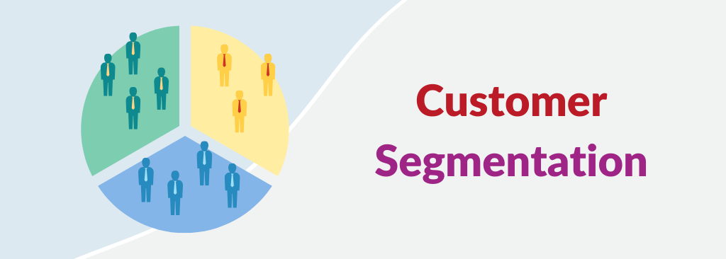

**APPLIED DATASCIENCE PHASE 2**

**TEAM MEMBERS:**

1. **U. SWATHI**
2. **A.VIDHYA**
3. **U.SNEHA SRI**
4. **K.PAVITHRA**

**DATA COLLECTION:**

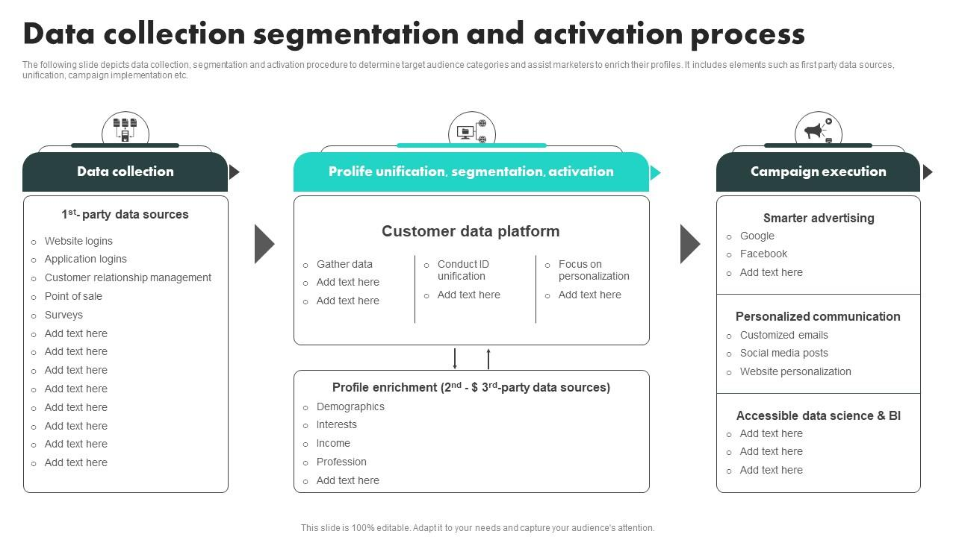

|  |  |
| --- | --- |
| |  | | --- | | https://mail.google.com/mail/u/0/images/cleardot.gif | |

**Surveys are a great way to get data related to demographics, purchasing patterns, preferences, and other distinct categories. You can also use interviews, existing customer data, focus groups, and other data collection methods.**

**Customer Satisfaction Tools**

1. **Net Promoter Score.**
2. **Live Chat.**
3. **Social Media Mentions.**
4. **Marketing Emails.**
5. **Short Message Service (SMS)**
6. **Churn Rate.**
7. **Follow-Up Surveys**

**DATA INSPECTION:**



|  |  |
| --- | --- |
| |  | | --- | | https://mail.google.com/mail/u/0/images/cleardot.gif | |

**Data inspection in customer segmentation refers to the systematic examination and analysis of the data collected from customers or potential customers in order to understand its quality, characteristics, and suitability for segmentation purposes. This process involves inspecting the data to identify patterns, trends, anomalies, and other important insights that will inform the segmentation strategy. It is a critical step in the customer segmentation process as it helps ensure that the data used for segmentation is clean, relevant, and of high quality, which, in turn, leads to more accurate and effective customer segments.**

**DATA CLEANING:**

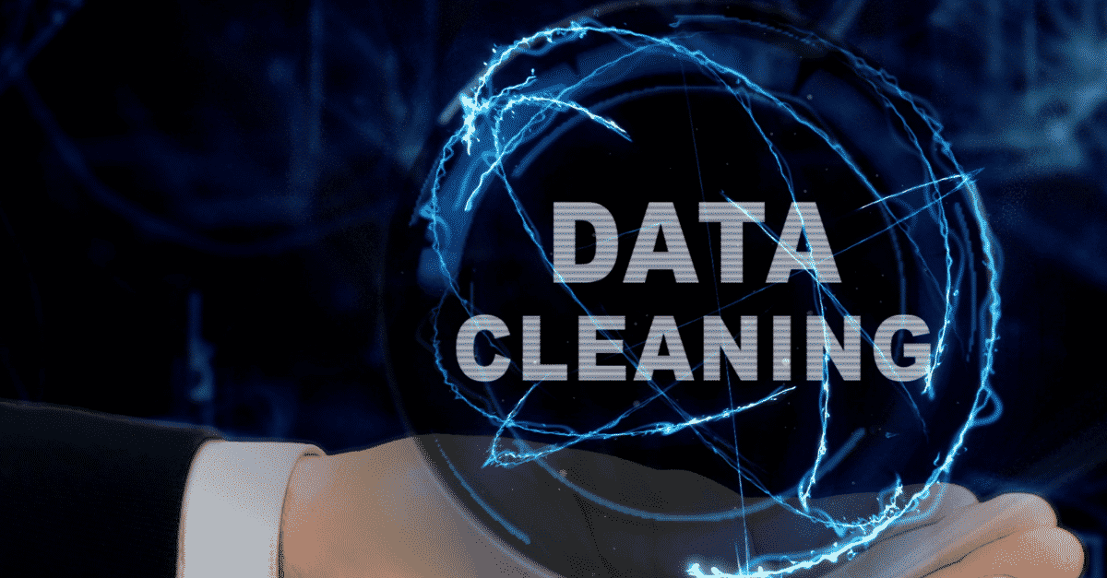

**Data cleaning is the act of sifting through your data to detect and correct inaccuracies or any corrupted elements. It is especially valuable for digital marketers who are combining performance data from multiple sources. It is part of the overall data management process.**

**DATA TRANSFORMATION:**

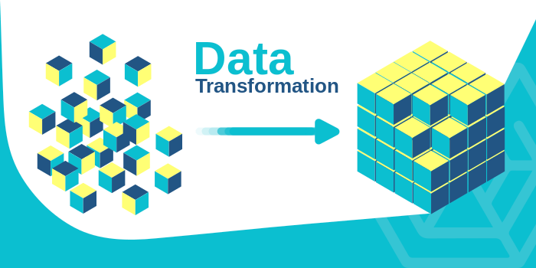

**Data transformation in customer segmentation is the set of procedures and operations applied to customer data to make it more usable, consistent, and relevant for the purpose of creating meaningful customer segments. This may include actions such as encoding categorical variables, scaling numerical features, handling missing values, creating new features, or reducing dimensionality.**

**The transformed data provides a solid foundation for generating customer segments that can be used for targeted marketing, product customization, and other business strategies.**

**EXPLORATORY DATA ANALYSIS:**

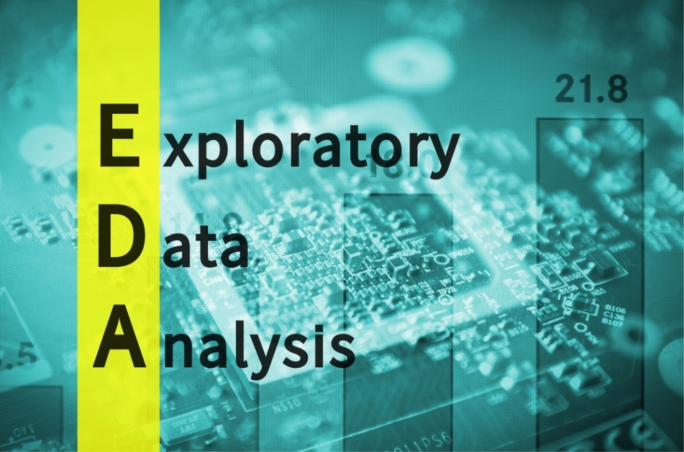

**Exploratory data analysis (EDA) in customer segmentation is the process of examining and visualizing customer data to gain a preliminary understanding of its key characteristics, patterns, and relationships.**

**EDA helps in uncovering valuable information about customer behavior, preferences, and demographics, which is crucial for creating effective customer segments and enhancing marketing and business strategies.**

**DATA VISUALIZATION:**

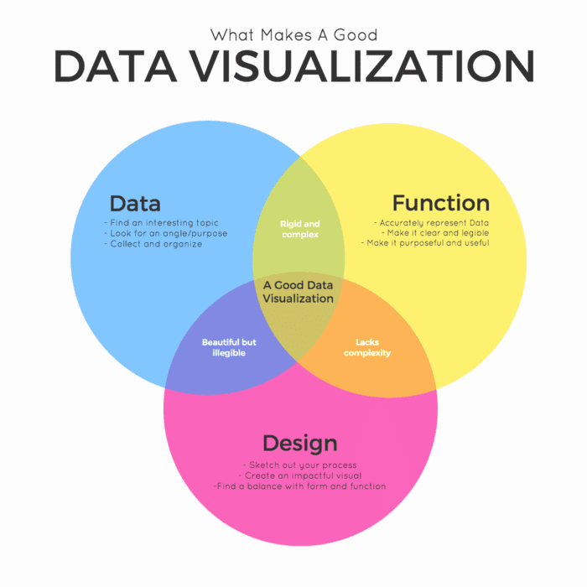

**In various tools and formats to create visual representations of your segments, such as charts, graphs, tables, dashboards, or infographics. The goal is to make your segments easy to understand and compare and to highlight the key differences and opportunities among them.**

**4 Simple Steps to Customer Journey Data Visualization**

1. **Step 1: Define the Main Aspects of the Customer Experience.**
2. **Step 2: Choose the Right Data to Visualize.**
3. **Step 3: Choose the Right Data Visualization Tools.**
4. **Step 4: Get Actionable Insights and Make Better Decisions.**
5. **Conclusion.**

**DATA SPLITTING:**

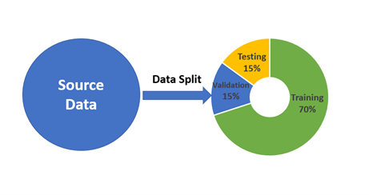

**Data splitting is when data is divided into two or more subsets. Typically, with a two-part split, one part is used to evaluate or test the data and the other to train the model. Data splitting is an important aspect of data science, particularly for creating models based on data.**

**DATA PREPROCESSING:**

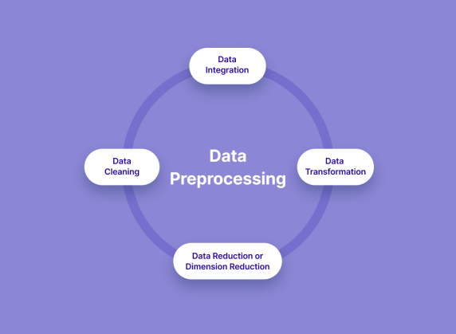

**Data Segmentation is the process of taking the data you hold and dividing it up and grouping similar data together based on the chosen parameters so that you can use it more efficiently within marketing and operations.**

**The steps to be taken are:**

1. **Read image.**
2. **Resize image.**
3. **Remove noise(Denoise)**
4. **Segmentation.**
5. **Morphology(smoothing edges)**

**MALL CUTOMER SEGMENTATION DATA**

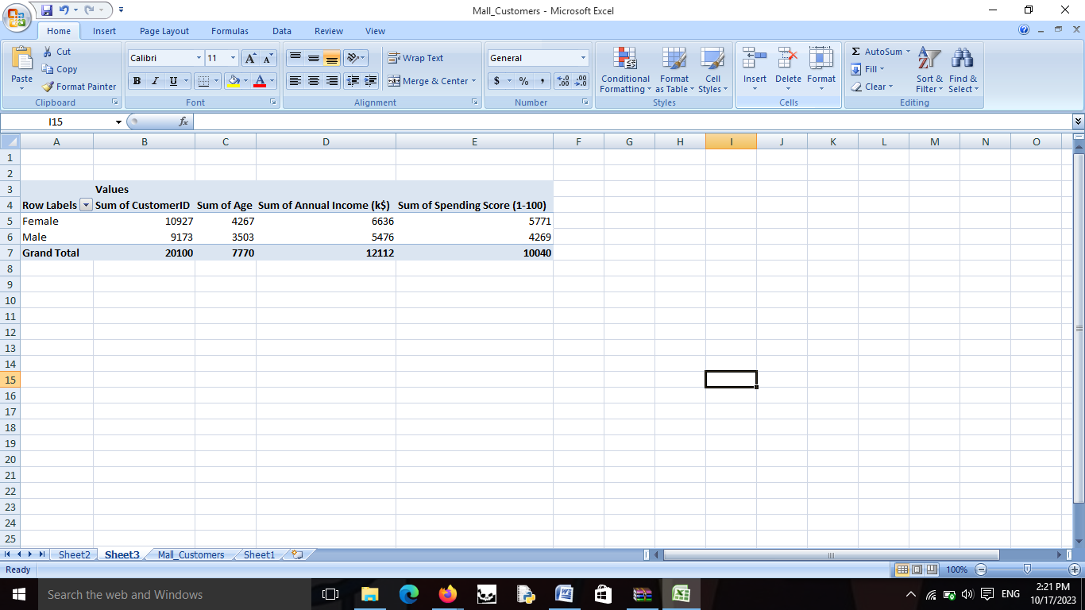

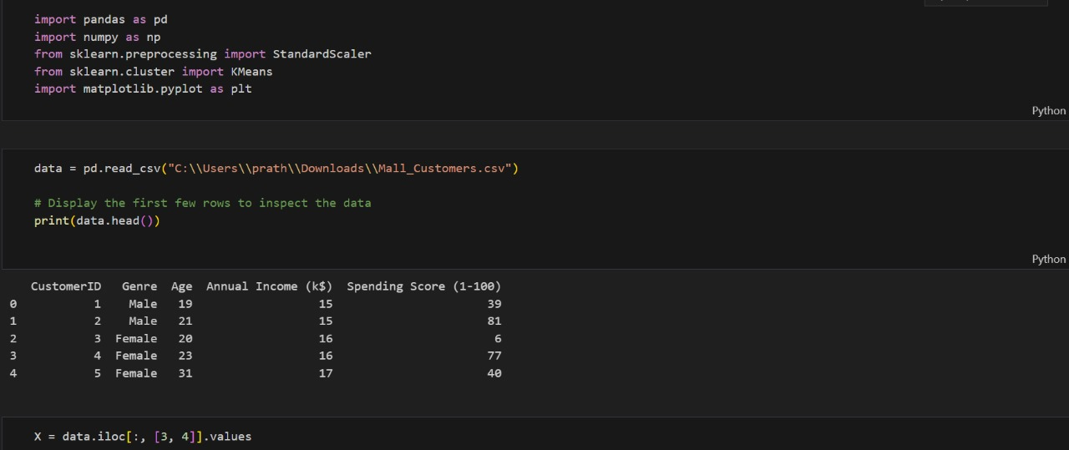

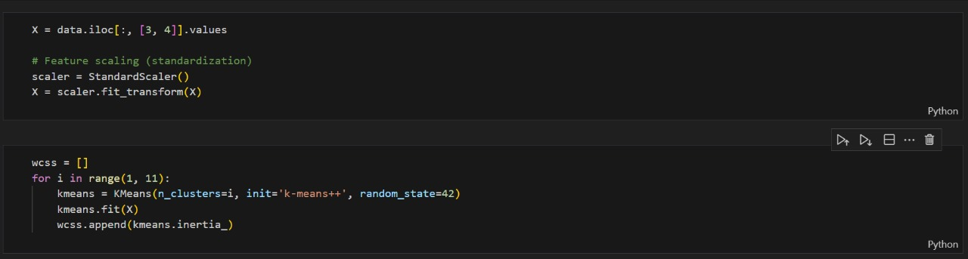

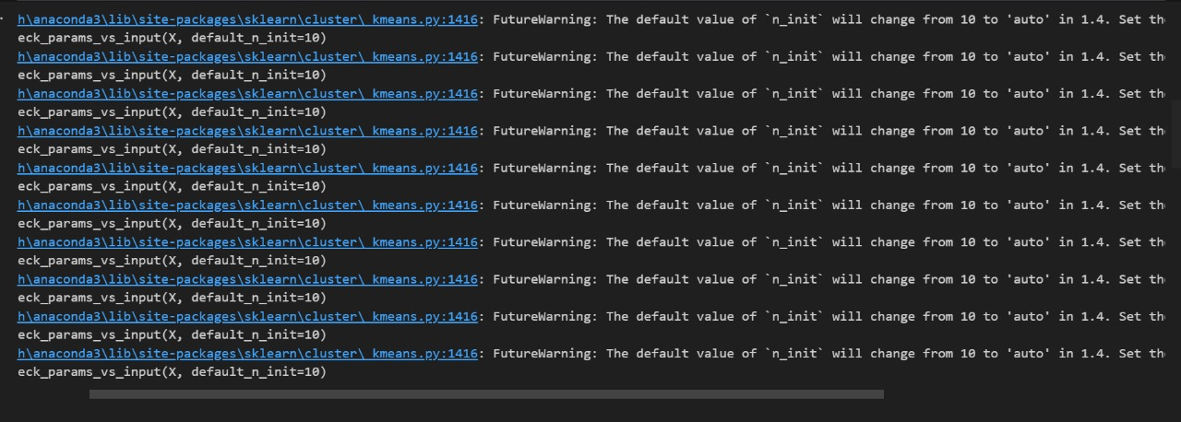

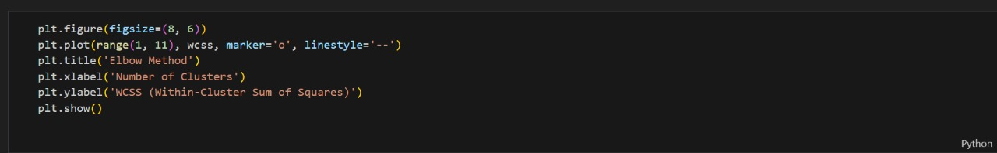

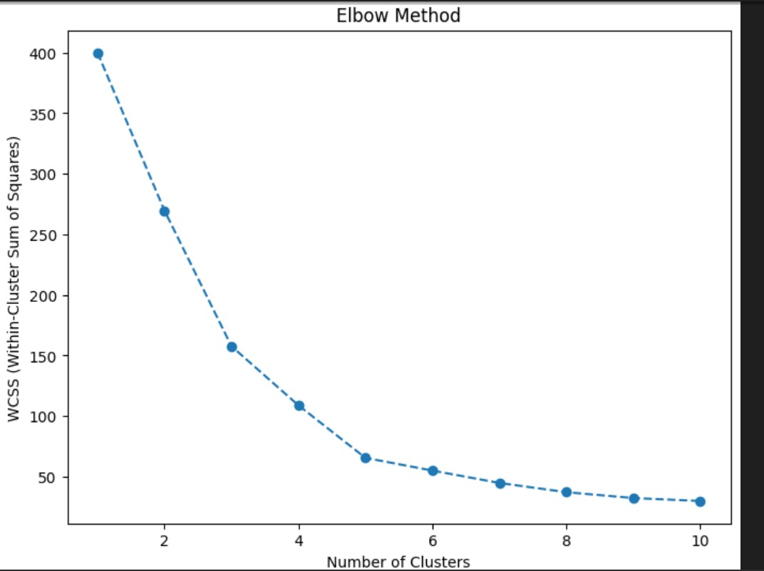

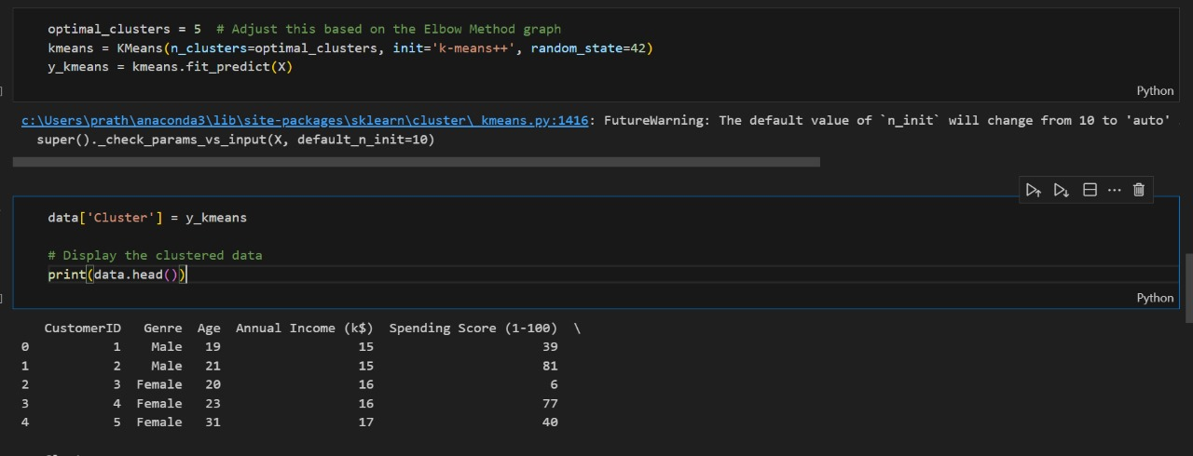

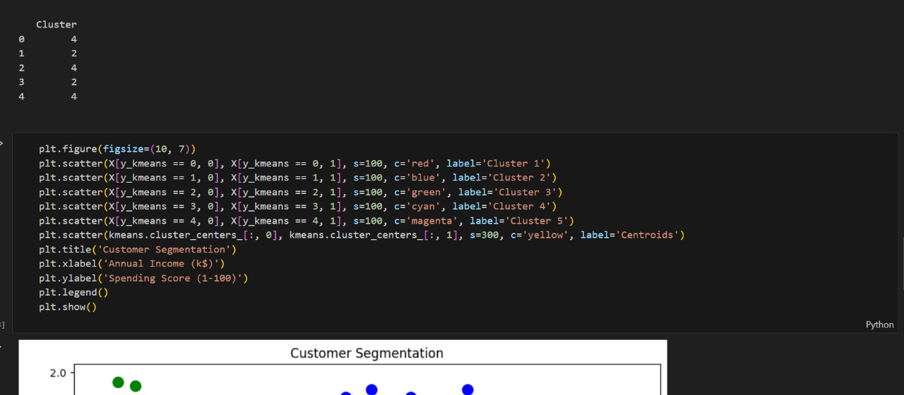

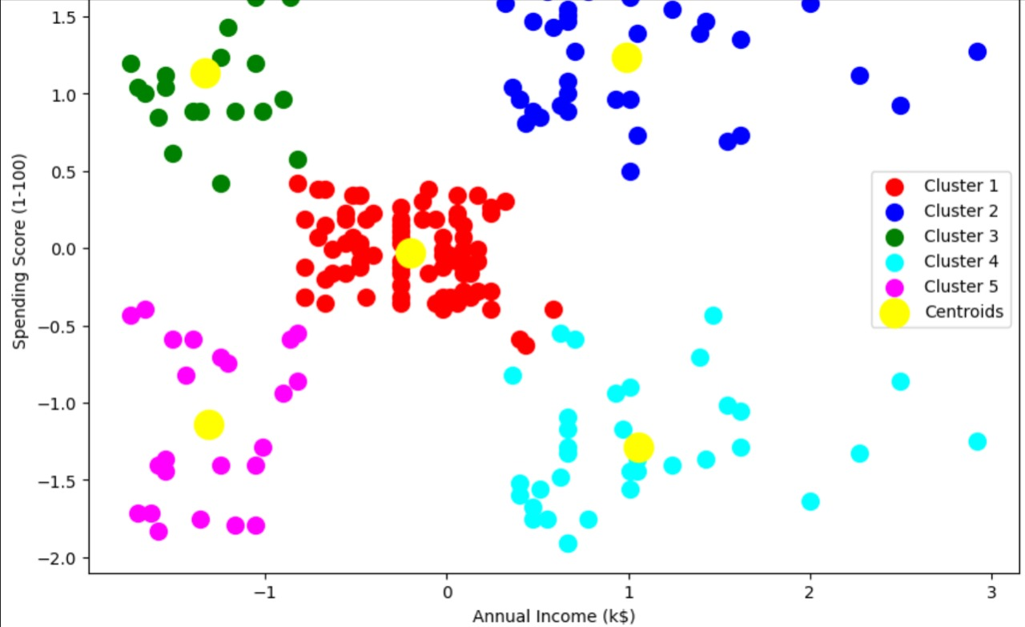

**THANK YOU**

**SUBMITTED BY:**

**U. SWATHI**

**3RD YEAR CSE**